**Sunkari Manohar**

**Aditya Institute of Technology and Management**

**Assessment 5-8/12/2023**

**Equi Join:**

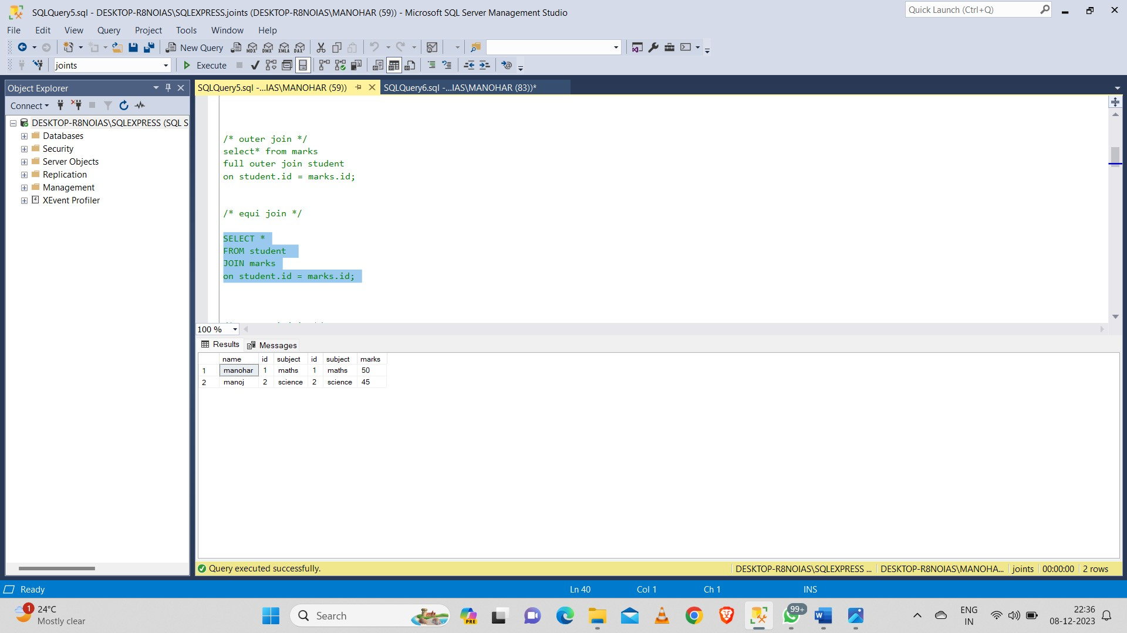

**Non Equi Join:**

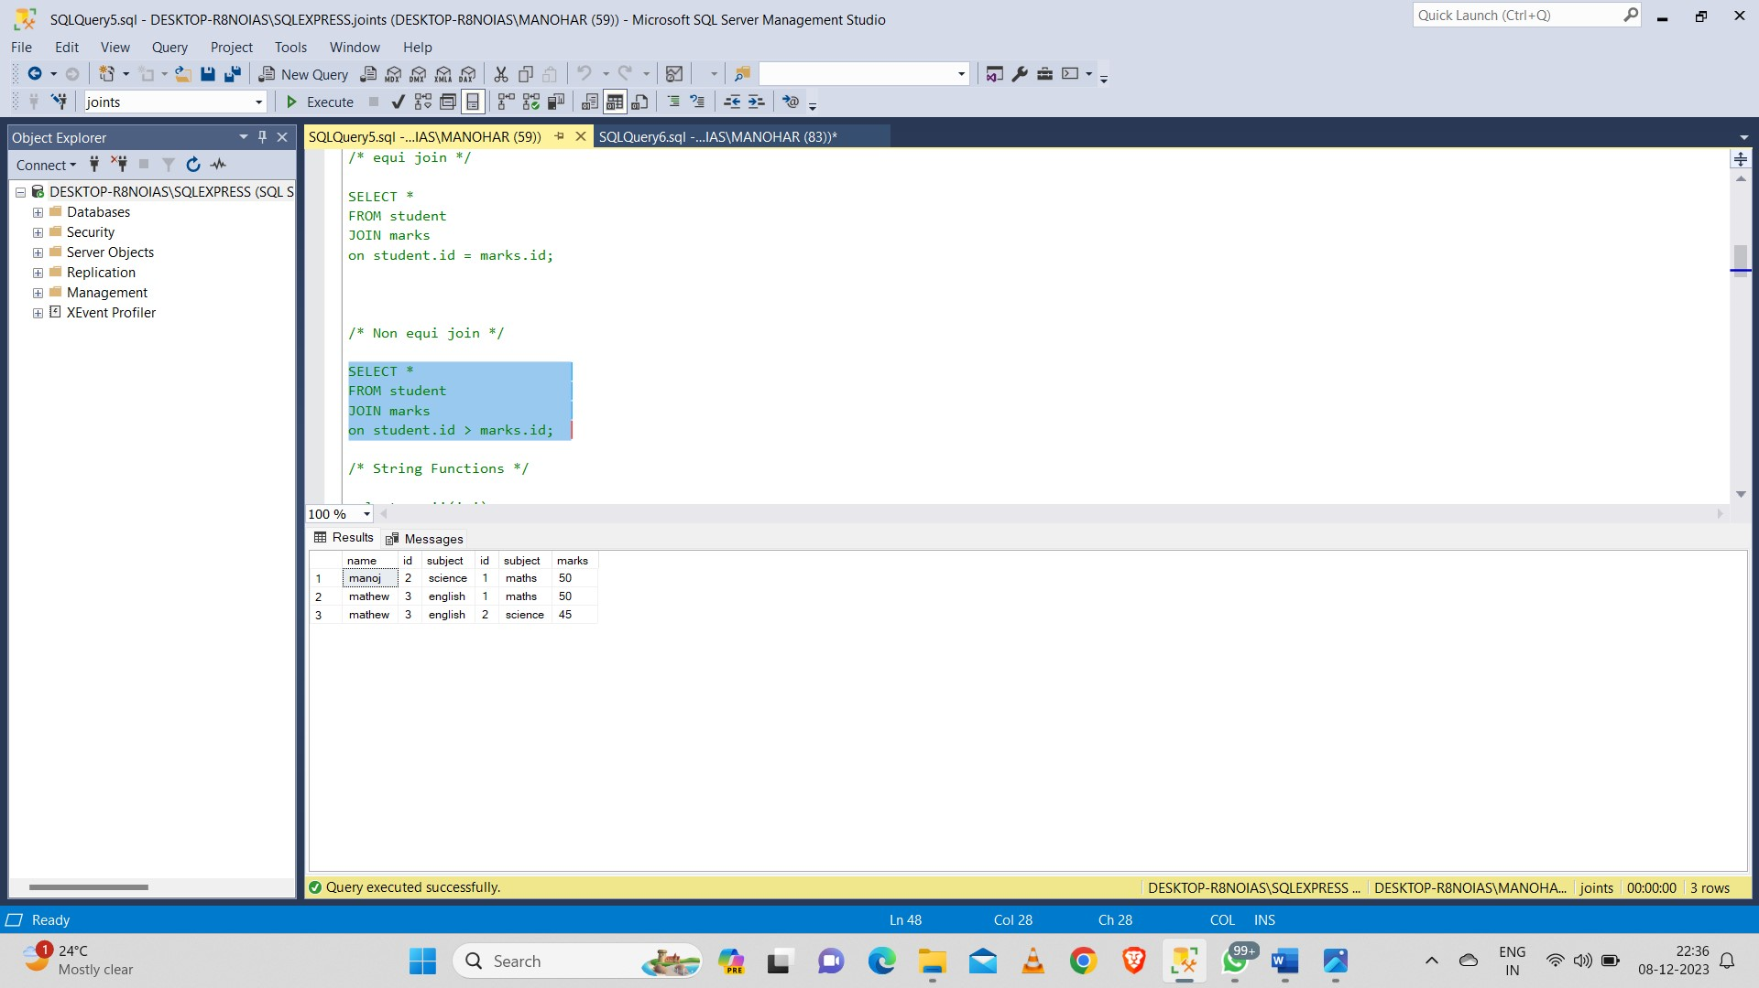

**Subqueries:**

**Using select:**

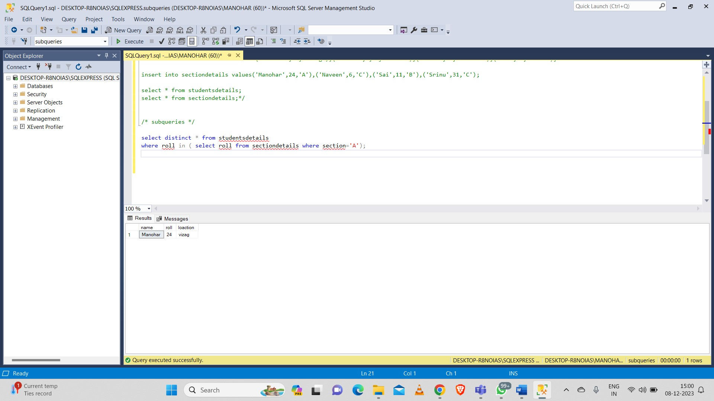

**Using Update:**

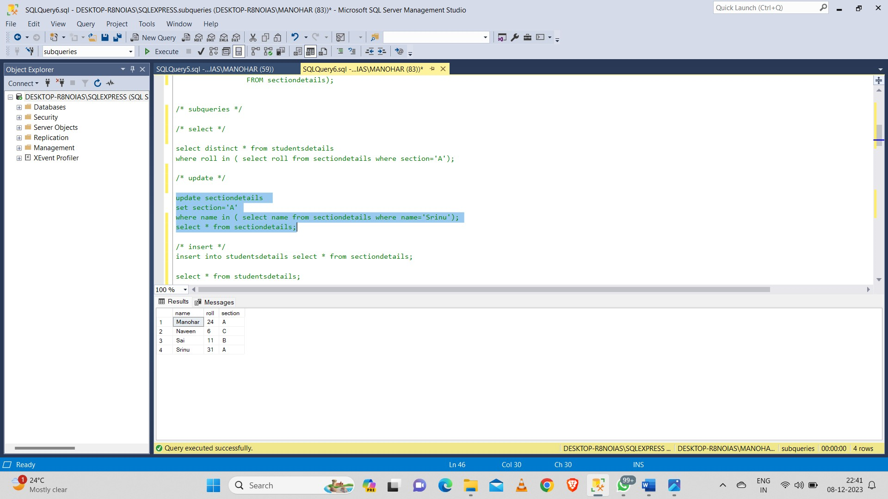

**Using Insert:**

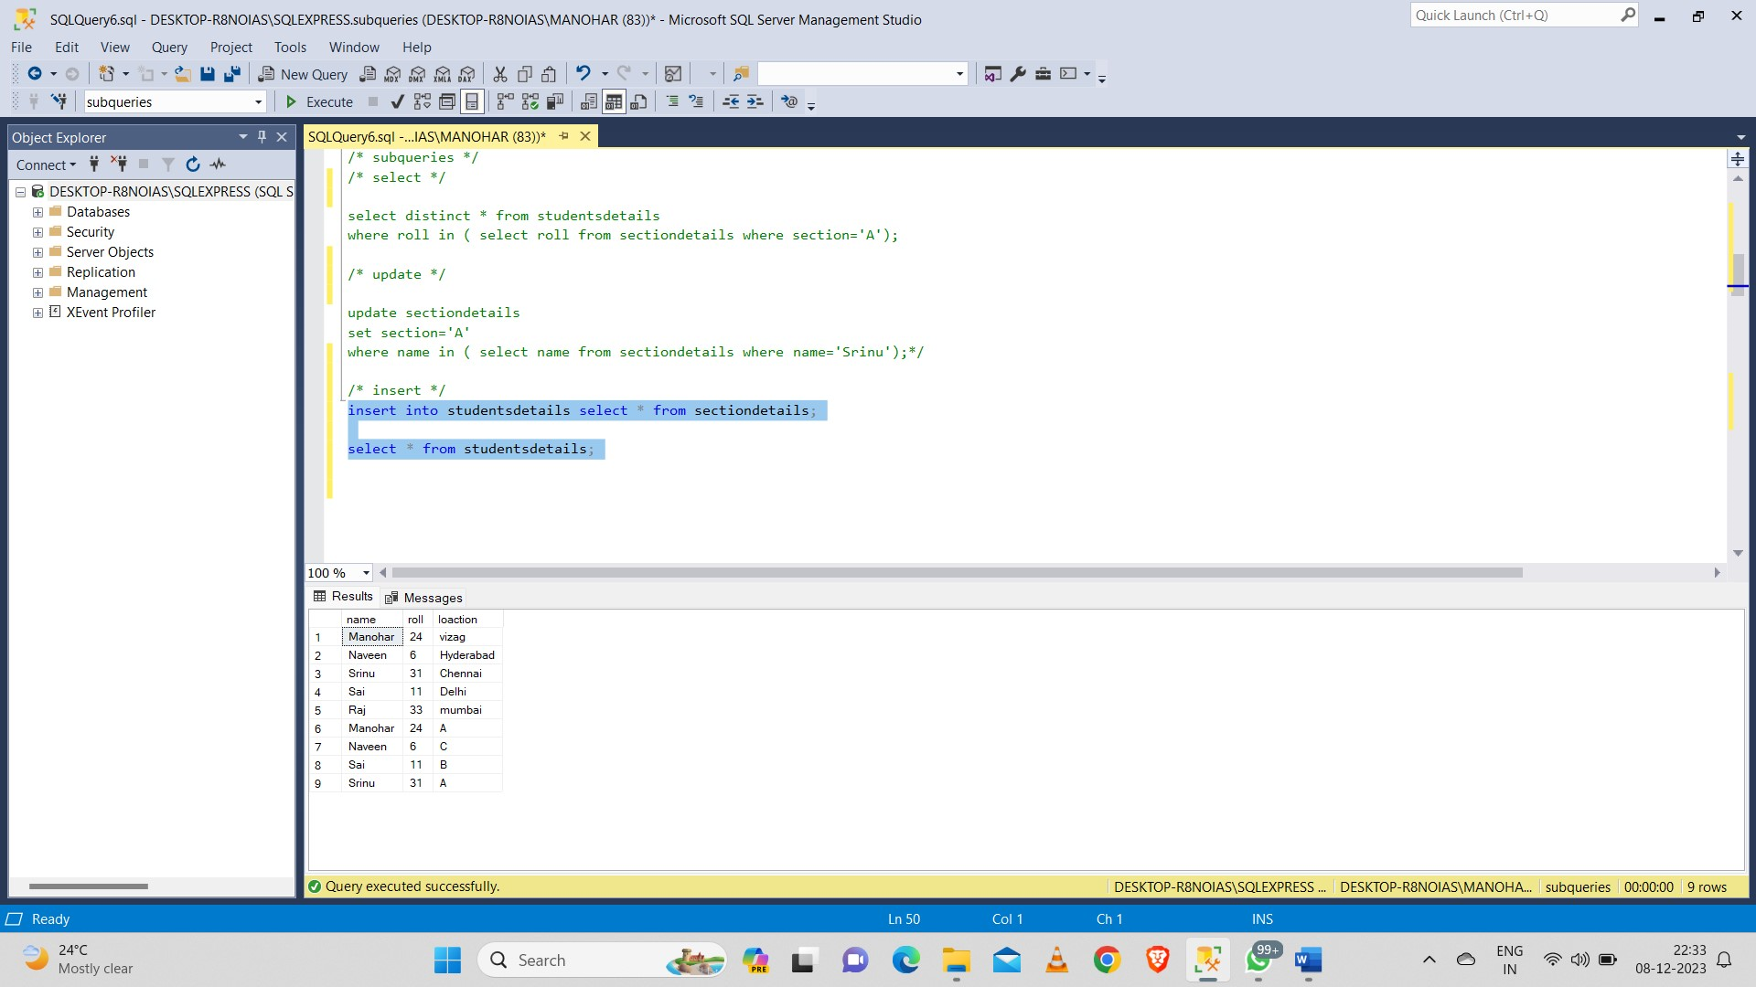

**Exists Keyword:**

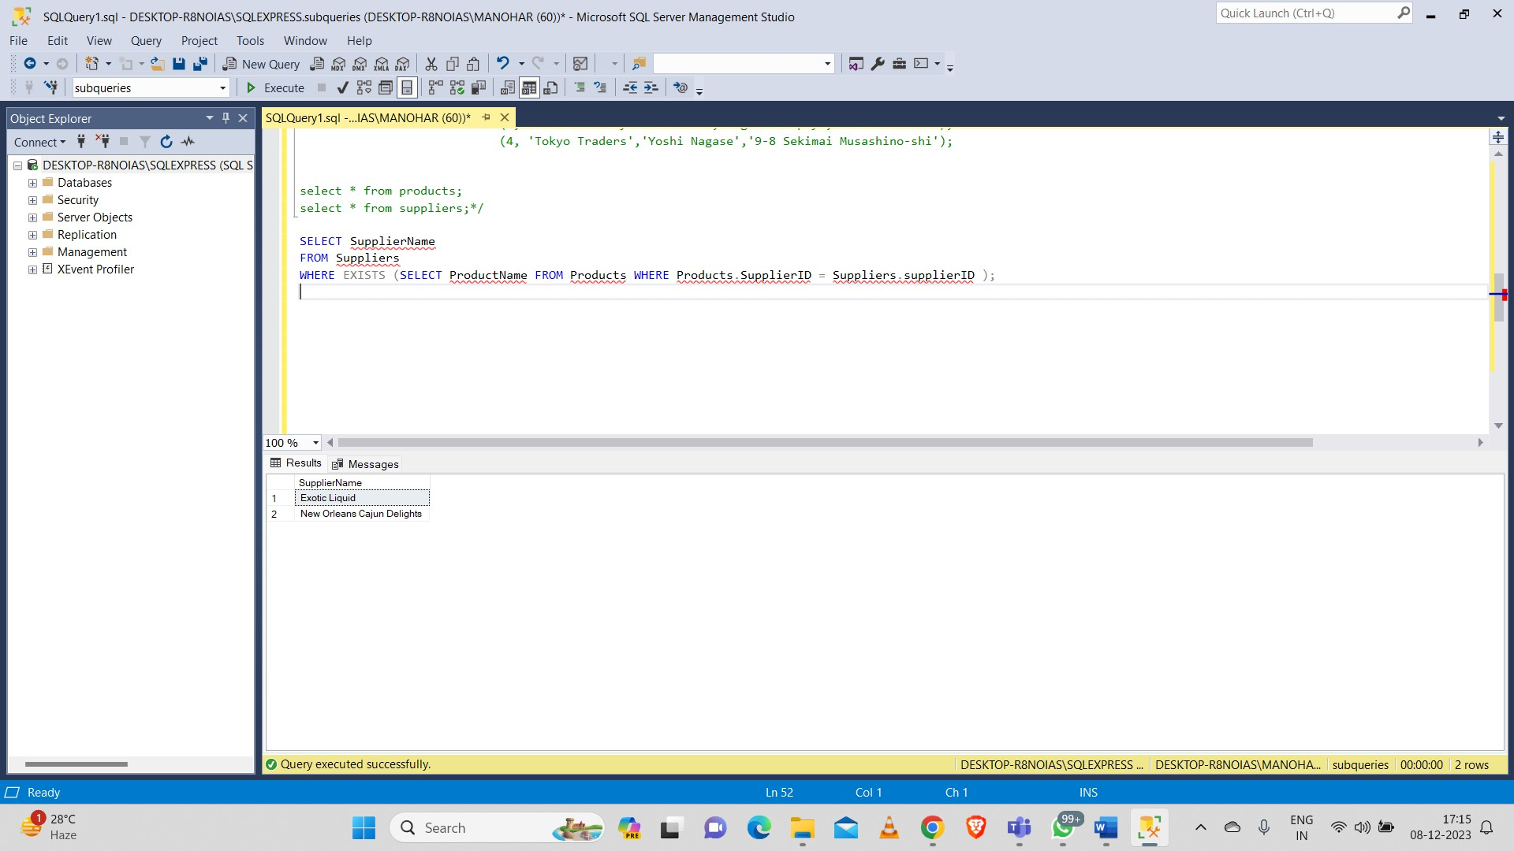

**Any Keyword:**

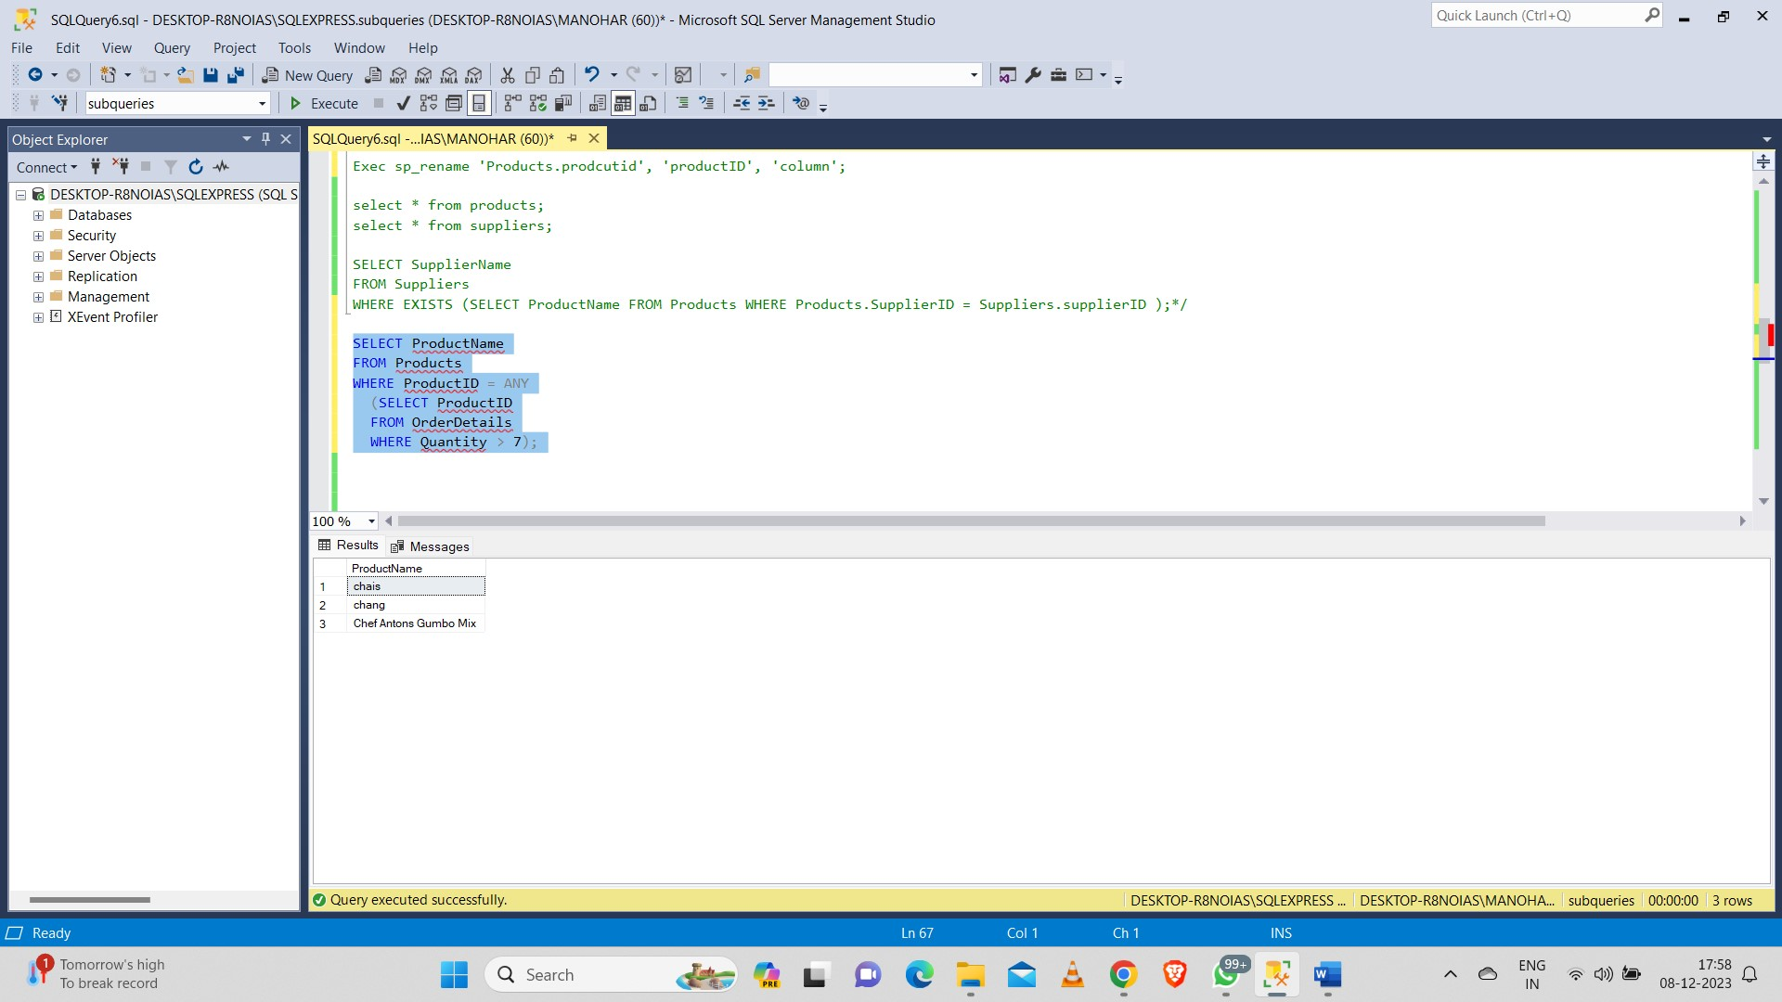

**All Keyword:**

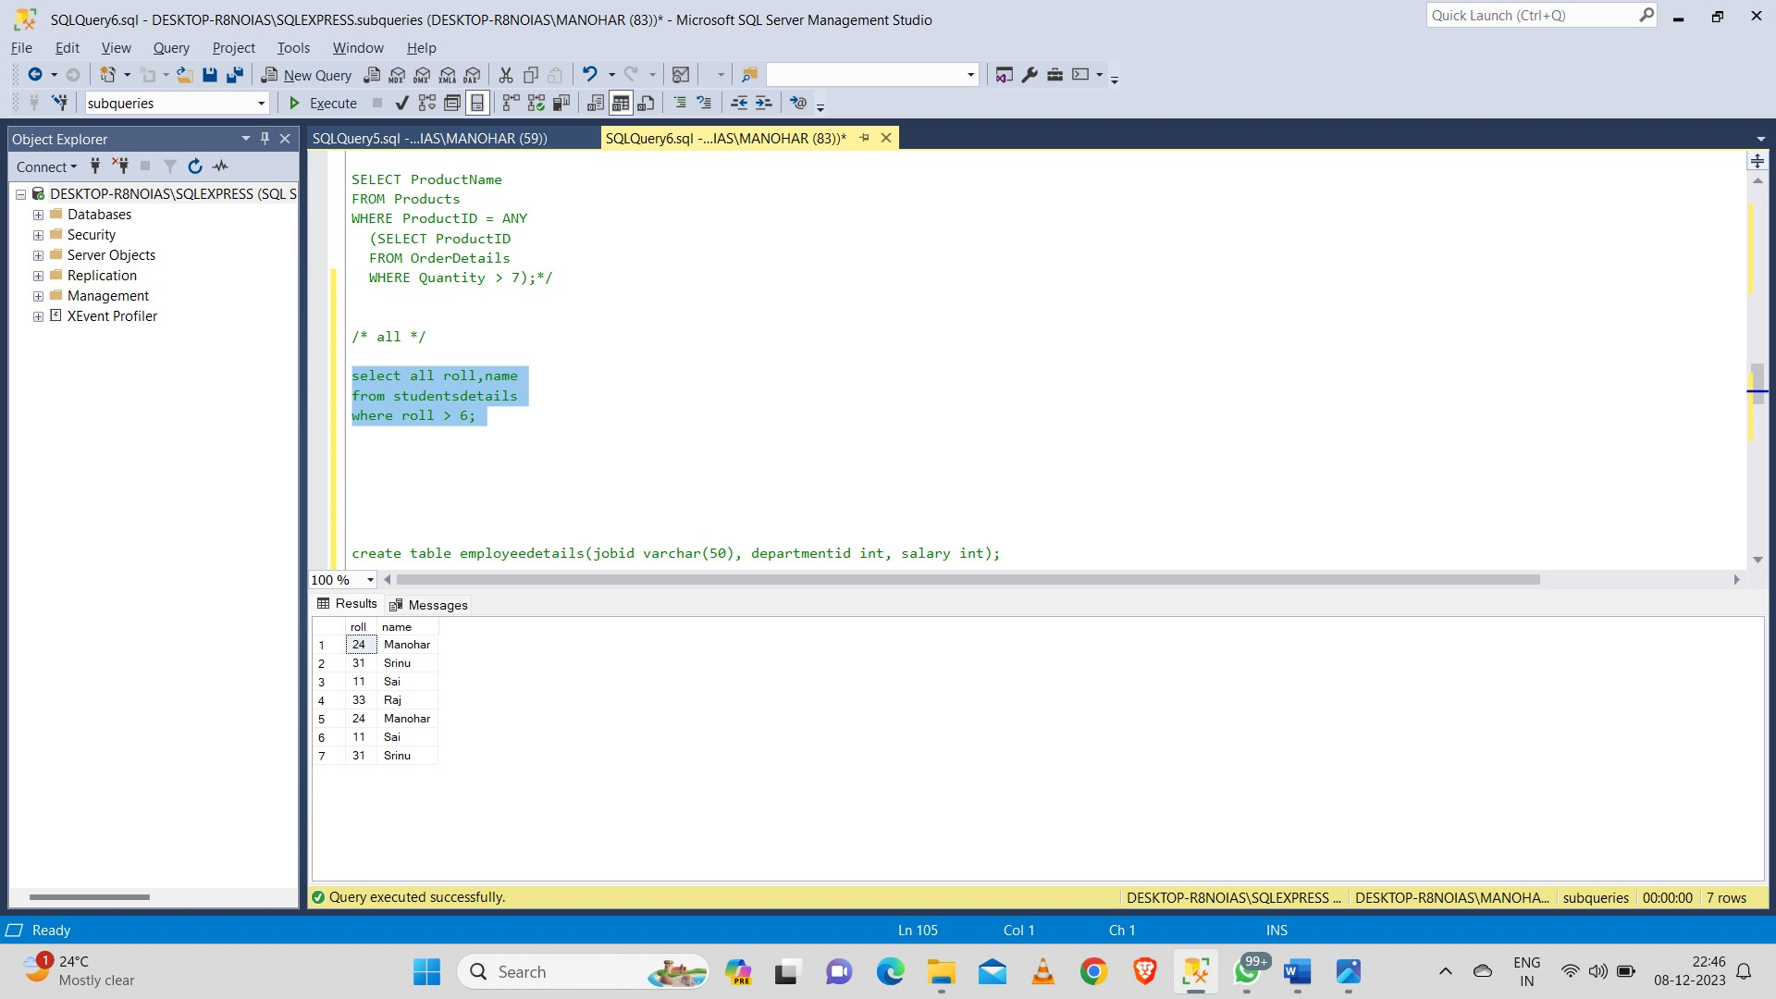

**Set Memberships:**

**In:**

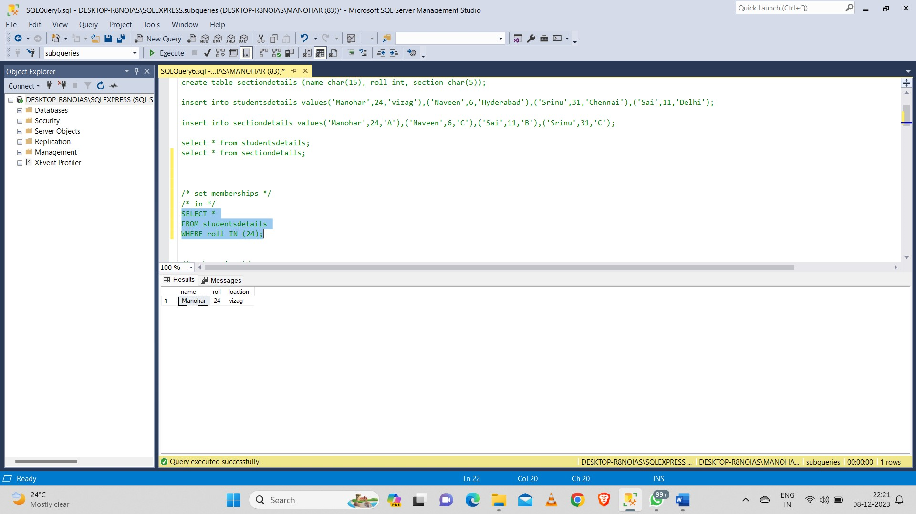

**Not in:**

